1. To-Do:
   1. Design Organizational Hierarchy of AR Parts
   2. Define a “Completed Build“
   3. Make a Python Program that web scrapes for all of these items from PalmettoStateArmory.com
      1. Lower Parts
         1. Stripped Lower Receiver
         2. Trigger
         3. Buffer Assembly Kit
         4. Stock
         5. Pistol Grip
      2. Upper Parts
         1. Stripped Upper
         2. Forward Assist
         3. Dust Cover
         4. Barrel
         5. Handguard
         6. Gas Tube
         7. Gas Block
         8. Bolt Carrier Group
         9. Charging Handle
   4. Backup the MVP parts data somewhere(Google Drive) so ur gucci if the site changes/updates
   5. Categorize them in a SQL Server/Format using MongoDB
   6. Design WebPage using HTML/CSS
   7. Connect them with Django
2. Design Organizational Hierarchy of AR Parts
   1. Lower Parts
      1. Lower Parts Kit (trigger included by option)
      2. Trigger
      3. Buffer Kit
      4. Stock
      5. Pistol Grip
   2. Upper Parts
      1. Stripped Upper, Assembled Upper, or Complete Upper
      2. Forward Assist
      3. Dust Cover
      4. Barrel
      5. Handguard
      6. Gas Tube
      7. Gas Block
      8. Bolt Carrier Group
      9. Charging Handle
      10. Muzzle Device (optional but not required)
      11. Attachments (optional but not required)
   3. Part Variables (What is known about each part)
      1. Component, Selection(Photo, and Name), Price, and Ship Date, Dealer, Link to Buy or look at product
      2. Example:



* 1. Define a “Completed Build”
     1. The component, Selection(name at the minimum), dealer, and link to buy for the following components
        1. Lower Parts Kit
        2. Trigger
        3. Buffer Kit
        4. Stock
        5. Pistol Grip
        6. Stripped Upper
        7. Forward Assist
        8. Dust Cover
        9. Barrel
        10. Handguard
        11. Gas Tube
        12. Gas Block
        13. Bolt Carrier Group
        14. Charging Handle

1. Web Scraping to Build Part DB within SQL, and later on a user DB within SQL also
2. HTML/Javascript to build site UI
   1. Part Requirements Starting Screen
      1. PCPartPicker example

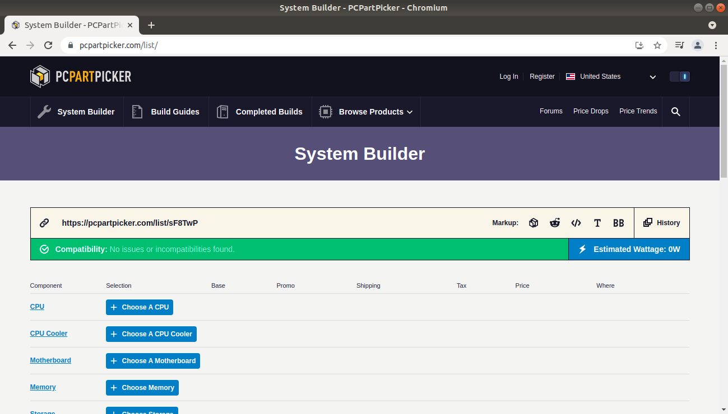

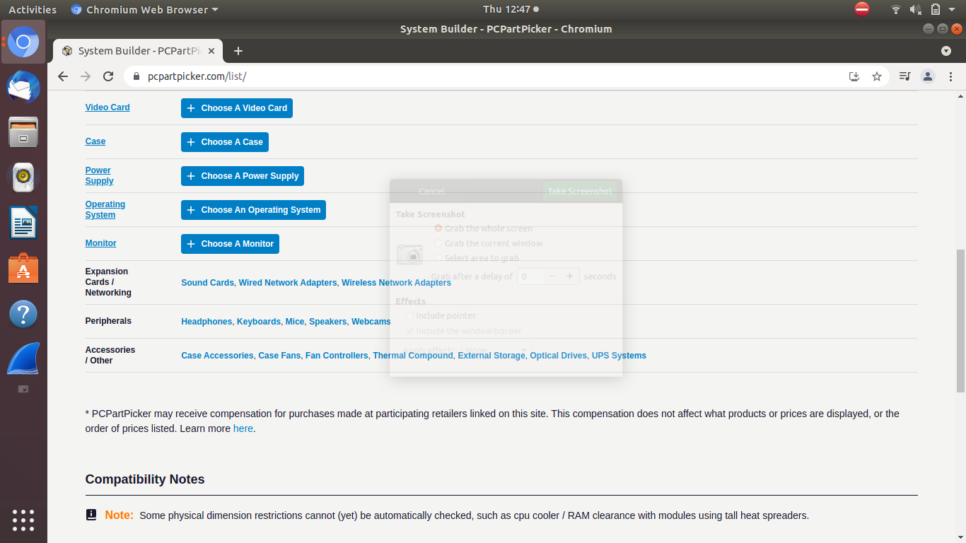

1. Backend using Python/Django